# 

# 

# Introduction to Computer Vision Lab 04: OpenCV Edge Detection and Blurring

# Instructor: Dr Tariq bashir

# Hamdan Sethi SP23-BAI-015

**Code Files:**

1- [Main](https://github.com/hvmdvvn/Intro-to-Computer-Vision/blob/main/Lab_02_Drawing_Functions.ipynb)  
2- Report

**Task 01: Advanced Edge Detection Techniques**

Edge detection is an image-processing technique that is used to identify the boundaries (edges) of objects or regions within an image. Edges are among the most important features associated with images. We know the underlying structure of an image through its edges. Computer vision processing pipelines, therefore, extensively use edge detection in applications.

**Sobel Edge Detection:**

Sobel Edge Detection is one of the most widely used algorithms for edge detection. The Sobel Operator detects edges marked by sudden changes in pixel intensity, as shown in the figure below.

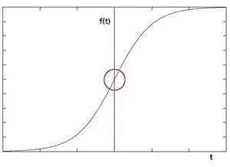

The rise in intensity is even more evident when we plot the first derivative of the intensity function.

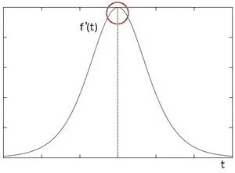

The above plot demonstrates that edges can be detected in areas where the gradient is higher than a particular threshold value. In addition, a sudden change in the derivative will also reveal a change in the pixel intensity. With this in mind, we can approximate the derivative using a 3×3 kernel. We use one kernel to detect sudden changes in pixel intensity in the X direction and another in the Y direction.

**SobelX:**

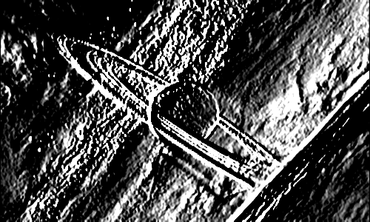

**SobelY:**

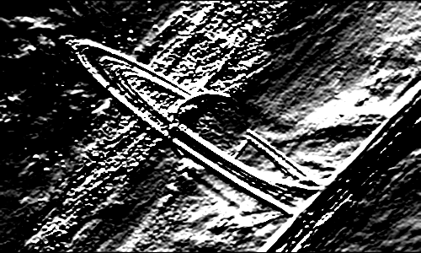

**SobelXY:**

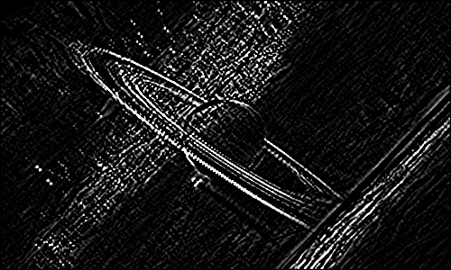

**Canny Edge Detection:**

Canny Edge Detection is one of the most popular edge-detection methods in use today because it is so robust and flexible. The algorithm itself follows a three-stage process for extracting edges from an image. Add to it image blurring, a necessary preprocessing step to reduce noise. This makes it a four-stage process, which includes:

* Noise Reduction
* Calculating the Intensity Gradient of the Image
* Suppression of False Edges
* Hysteresis Thresholding

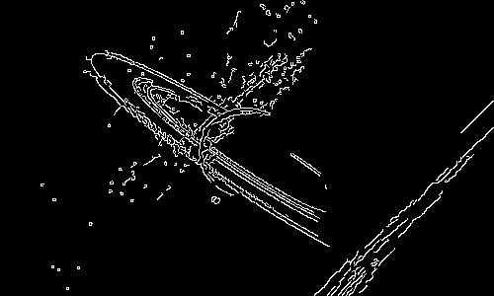

**Task 02: Custom Blurring Filters**

Image blurring is achieved by convolving the image with a low-pass filter kernel. It is useful for removing noise. It actually removes high frequency content (e.g: noise, edges) from the image resulting in edges being blurred when this is filter is applied.

**Averaging:**

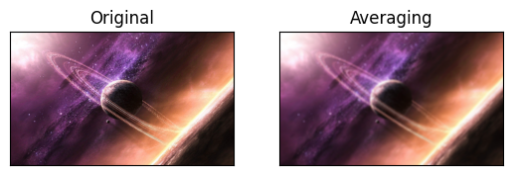

**Blurred:**

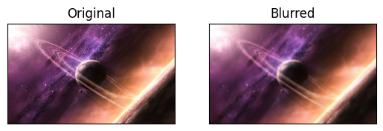

**Gaussian Blurred:**

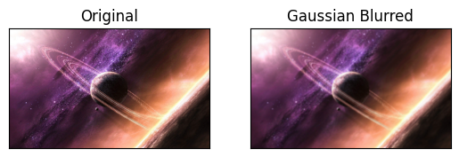

**Median Blurred:**

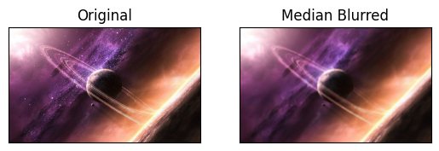

**Bilateral FIlter:**

